REVIEW OF 2021
CELEBRATING THE RE-OPENING OF CONCERT HALLS
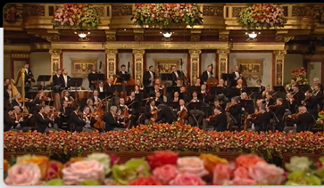
2021 saw musicians take to the stage again, starting with the world-renowned Vienna Philharmonic’s 2021 New Year’s Concert, featuring a variety of dances in the Viennese style, including the world-famous Strauss waltzes and rousing performances of Blue Danube and the Radetsky March - Essential Viewing!

